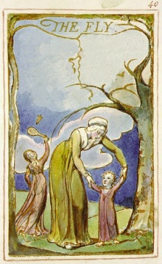
Hoping I don’t find you again
Because you cause me pain
Graduation is very soon
I don’t want to find you in my room

You are very annoying
It’s like a child smoking
Why are you everywhere
I am telling you, go away

Your time is always wrong
Wishing you get eaten by a frog
I even find you in school
I don’t think it is cool

Even when I tan you’re around
Even in the playground you’re found
If I hit you, you will die
Then I will get a suit and a tie

Fly O’ Fly go away
I hate you more everyday
When it comes to killing
It is very thrilling

