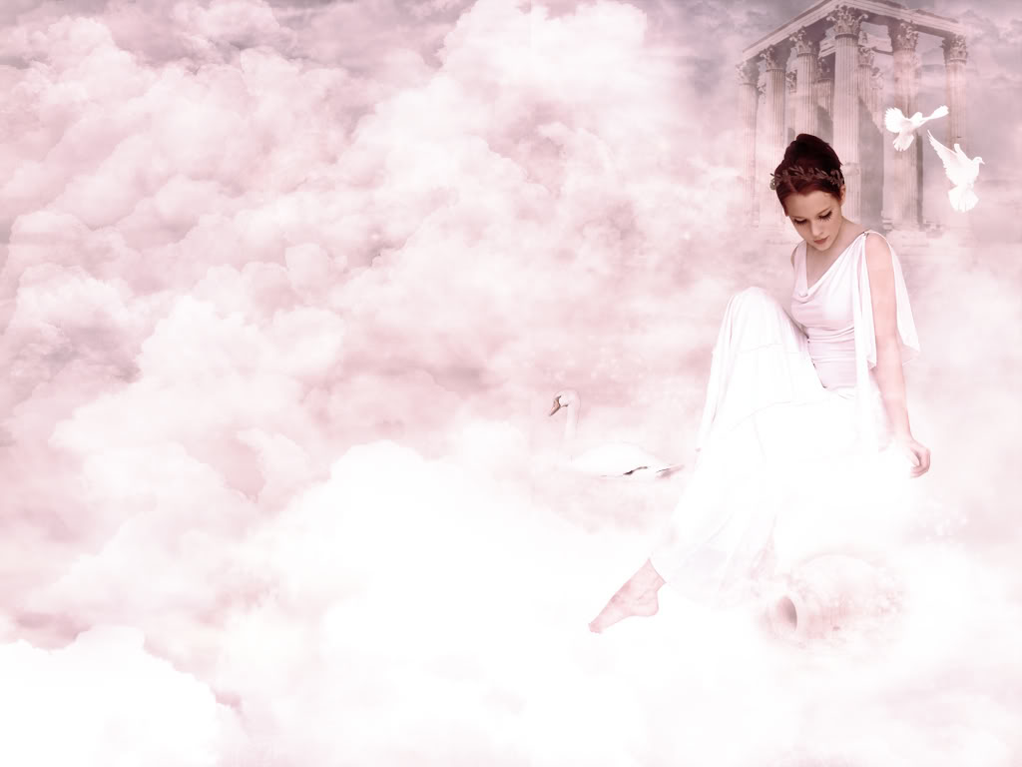
My sister’s personality is like a shine
She looks pretty, especially her eyes
People mostly pay attention to her smile
I think she attracts all the guys
One day I will be committing a crime
Or else I will be buying her a prize

Everything about her is very nice
Even her beauty and her style
I will never sell her, not with any price
Also if guys tried, for a while
I will kick them in the head twice
Because I know she is worthwhile

Her beauty is priceless like the moon
She is very pretty inside and out
And I think about us every night
We will spend time together every noon
And we will keep this relationship throughout

